CN7050
Intelligent Systems
Student ID: 3059676
Full Name: Mann Shrestha

LAB 3

- Baseline Model - before improvements (no tailoring, no clustering)

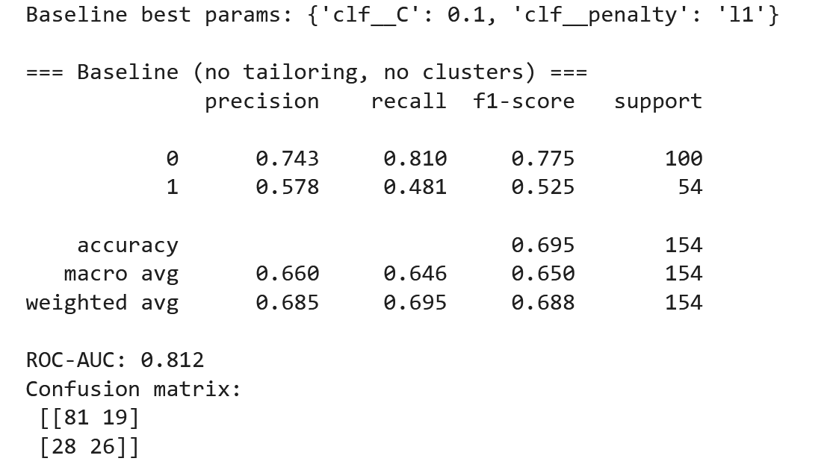

- Data Tailoring:

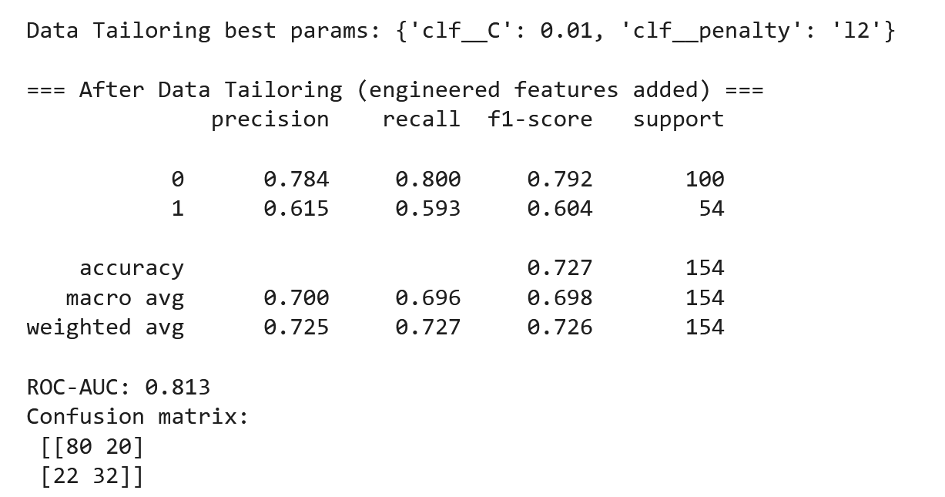

- Clustering + Prediction (add K-Means Phenotype ‘cluster_id’)
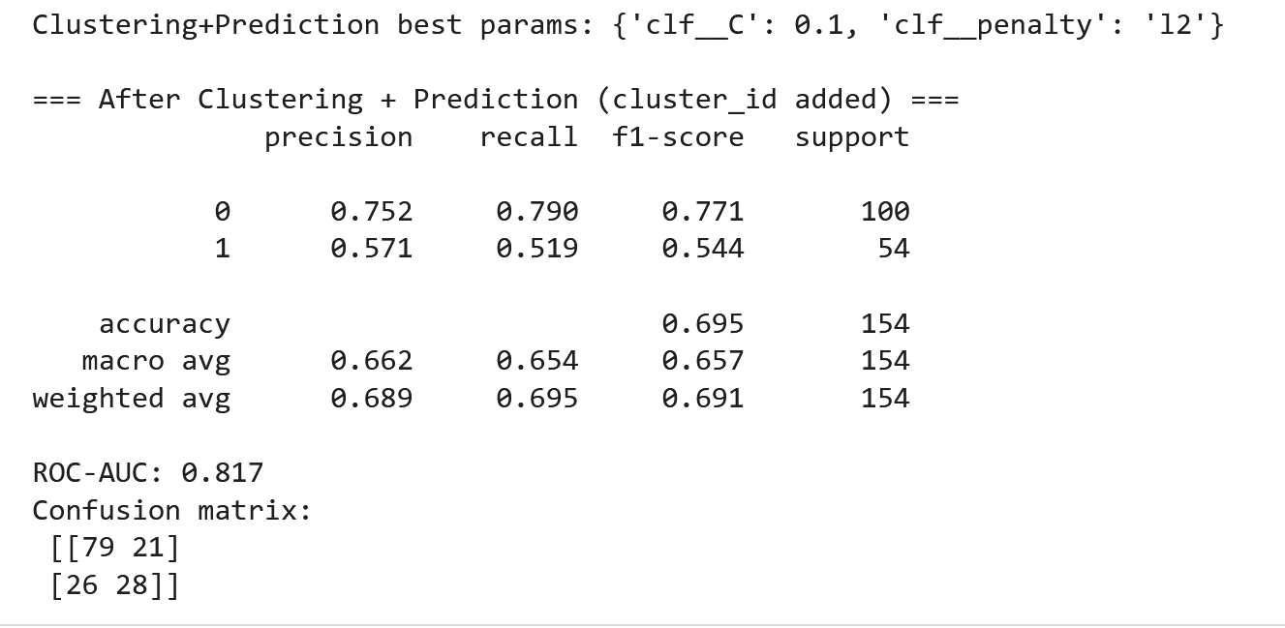

- MODEL ADAPTATION
- MODEL ADAPTATION (cohort shift: YoungAdults -> OlderAdults)

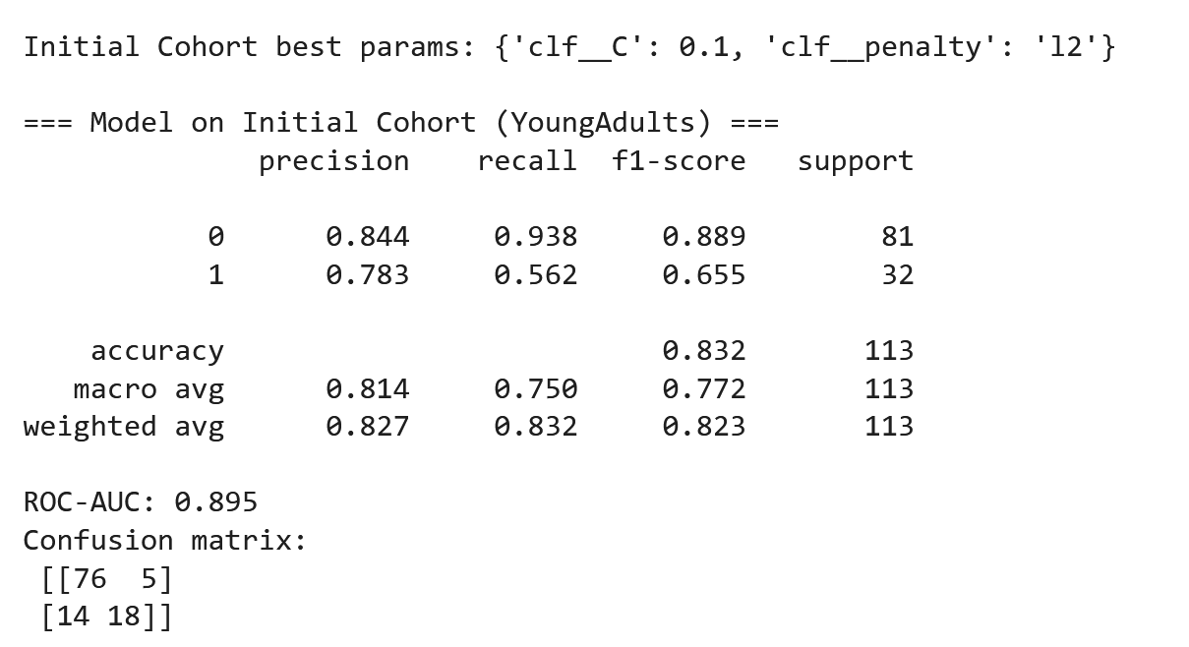

- After Adaptation (evaluated on OlderAdults)

